Adults, Teens & Families
Michigan State University Extension health and nutrition programs are offered at no cost to participants. Each class series meets for 6 sessions once a week, Starting August 15th Ending September 12th, Wednesdays at 6:30-7:45 at North Rosedale Park Community House, 18445 Scarsdale St. Det. 48223. Classes are taught in a small group format. Lessons are interactive, because health matters MSUE nutrition programs strive to bring information to life centering on taking steps to making healthy eating and being more physically active as part of a total lifestyle.
Education topics include but are not limited to:
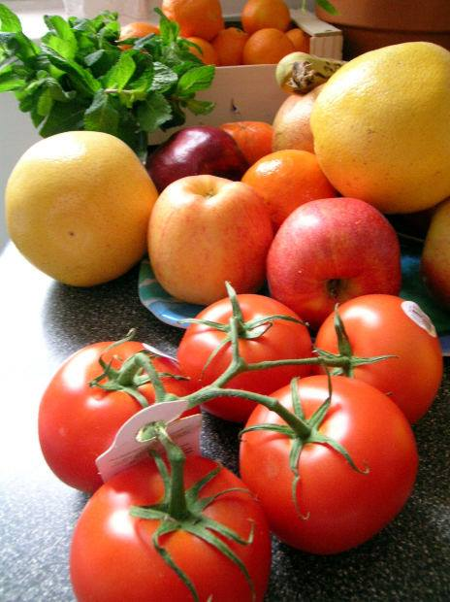
- Learning to eat healthy on a budget
- Choosing budget-friendly ingredients that are necessary to prepare healthy meals for families
- Learning about effects of sugar, sodium, and different types of fats
- Increasing physical activity and setting goals
- Discovering tips for reaching and maintaining a healthy weight
- Modifying a recipe to make it healthier
- Teaching cooking skills to help gain the knowledge and confidence participants need to prepare healthy meals and snacks
- Trying new foods through provided tastings
Building Better Lifestyles for Longer Healthier Lives
Join Us

